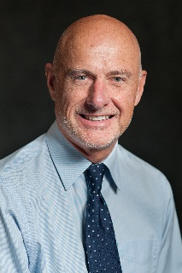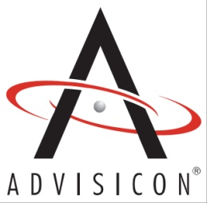

*Rick Gardner*

Director of Operations, Latin America

Rick.Gardner@Advisicon.com

Professional Summary

Rick Gardner is Advisicon’s Director of Operations for Latin America. Rick is also a Project Management Professional (PMP) certification through the Project Management Institute (PMI).

His 20 years of experience encompasses managing major International accounts as well as business development in Latin America; including strategic business plans and cultivating partnership opportunities. His strong customer-driven focus creates an environment for success in achieving business strategies, development of internal talent and capturing lessons learned to build intellectual assets for clients.

Accomplishments

* 20 years of in-depth experience
* Business development in North and Latin America
* Published author
* Deliver instruction of Project Management courses
* Guest instructor at Universidad Nacional Autonama de Mexico
* Effective relationship management and mentoring
* Analysis of obstacles and opportunities to achieve project goals
* Contract administration
* Document project plans, agreements, organizational campaigns
* Creative problem solving and successful negotiating
* Maintain strong relationships with internal and external customers
* Dynamic one-on-one and group presentations
* Prioritizing and organizing customer support
* Bilingual in Spanish - fluent in conversation and writing skills with excellent grammar, pronunciation, and vocabulary

Certifications

* PMP (Project Management Institute – Project Management Professional)

Education

* BA Administration, University of Oregon, Eugene, OR
* International Marketing, University of Pavia, Pavia, Italy
* Spanish Language Institute, Guadalajara, Mexico

Experience

Project Management

* Oversee multiple teams to accomplish project goals
* Utilize technologies (Microsoft Project, Project Server, SharePoint) to monitor project progress
* Creative problem solving and conflict resolution
* Develop multi-tiered reporting
* Evaluate project progress and make recommendation to deliver project success
* Contract administration
* Establish and monitor client and stakeholder expectations

Consulting/Business Development

* Analyze workflows and recommend continuous process improvement strategies
* Research and evaluate market trends
* Forecast market needs and develop market strategies
* Review and create plans in support organizational strategic goals
* Develop business solutions customized to organizations
* Investigate and analyze business develop opportunities in North and Latin America
* Develop partner agreements and disclosures
* Train and mentor internal resources to capture opportunities and leads
* Single point of contact to cultivate customer satisfaction

Training

* Develop course curriculum for proprietary courses
* Develop course materials
* Deliver interaction presentations to one-on-one and large groups
* Guest instructor at Universidad Nacional Autonama de Mexico

Publications

Gardner, Rick L. *Balanced Scorecard*. Portland, Oregon: Advisicon Press, 2005.

A training manual published in Spanish to present the concepts of Strategy Maps and Balanced Scorecard with the integration of best practices of Project and Project Portfolio Management for the purpose of executing an organization’s strategy to obtain tangible results.

Gardner, Rick L. *Desarrollo de una Metodología de Administración de Proyectos Empresarial Estratégica* – APEE. Mexico, D.F., Mexico, 2006.

A methodology published in Spanish and copyrighted in Mexico, to guide an organization toward maturity in the selection and management of strategic projects.

Contact

Phone: (866) 362-3847 Corporate (503) 317-0264 Cell

Email: [rick.gardner@Advisicon.com](mailto:rick.gardner@Advisicon.com)

URL: [www.Advisicon.com](http://www.Advisicon.com)